**Fruit and Grocery Website**

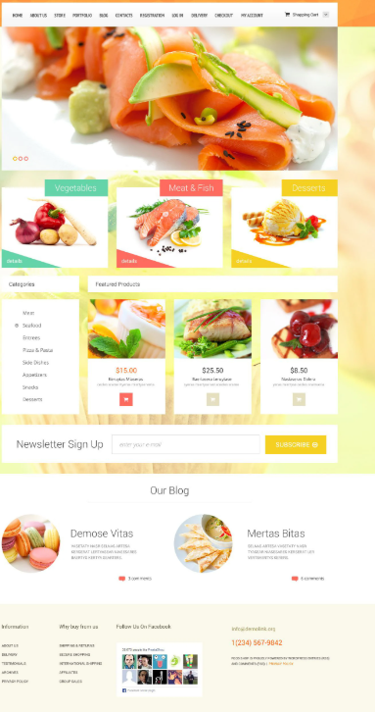

**BRIEF OVERVIEW OF THE PROJECT AND THE LIST OF FEATURES:**

* In that we create a different option for user like first of log in and sign up at home page.
* Then we add an option to select a choice for fruit grocery etc
* We also added a offers discount related details and session related fruits sale and offers
* We also added quantity and quality option and delivery option
* And also, we required a payment option and a feedback option .

**USER INTERFACE DESIGNS THAT SHOWCASE THE REALIZATION OF THE FEATURES LISTED ABOVE:**

1. **Padded Block Links**: Links (or anchors) are inline elements by default, which means that their clickable area spans only the height and width of the text. This clickable area, or the space where you can click to go to that link’s destination, can be increased for greater usability. We can do this by adding padding and, in some cases, also converting the link into a block element.

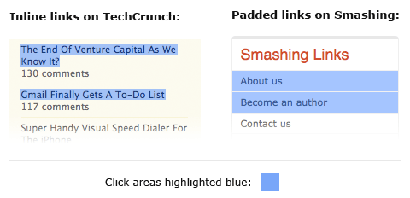

### Typesetting Buttons: Attention to every detail is what separates a great product from a mediocre one. Interface elements such as buttons and tabs are clicked on many times a day by your users, so it pays to typeset them properly; and by type setting I mean positioning the label.

### Badly typeset button labels

### Using Contrast to Manage Focus: Similarly, you can also manage the focus of your visitors’ attention with contrast between elements. Here’s an example of a post headline and some meta information underneath regarding who posted the article and its date

### Using Colour To Manage Attention: [Colour](https://www.smashingmagazine.com/2010/01/color-theory-for-designers-part-1-the-meaning-of-color/) can also be used to effectively **focus your visitors’ attention on important or actionable elements**. For example, during the US presidential election, pretty much all of the candidates’ websites had the donation button coloured red. Red is a very bright and powerful colour so it attracts attention, and it stands out even more when the rest of the website is blue or another colder colour.

### White Space Indicates Relationships: One of the most crucial elements in an interface is the white space between elements. If you’re not familiar with the term white space, it means just that: space between one interface element and another, be it a button, a navigation bar, article text, a headline and so on. By manipulating white space, we can indicate relationships between certain elements or groups of elements.

### Auto-Focus on Input: Many Web applications and websites feature forms. These may be search forms or input forms inviting you to submit something. If this form is the **core feature** of your application or website, you may want to consider **automatically focusing the user’s cursor on the input field** when the website loads. This will speed things up because users can start typing right away without having to click on it. A good example of this is Google and Wikipedia’s websites.

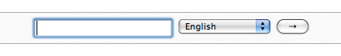

### Hover Controls: Some Web applications have extra utility controls, such as edit and delete buttons, that don’t necessarily have to be shown beside every item at all times. They can be hidden to **simplify the interface and focus visitors’ attention on the main controls and content**.

### INFORMATION ABOUT THE APPLICATION FLOW AND NAVIGATION STRUCTURE:

Many of aspects of web design and development play into user experience:

* Fonts, colours, and images
* Headlines
* Availability of contact information
* [Page load time](https://www.crazyegg.com/blog/speed-up-your-website/)
* [Form design](https://www.crazyegg.com/blog/form-design/)

### People visit lots of website every day, so they have no shortage of places to find what they want. If you don’t offer a clear website navigation menu, breadcrumbs, and other ways to explore your site, they won’t bother.

### Interface design - Link added to adobe xd prototype. Please check the link as I’ve worked very hard on this. https://xd.adobe.com/view/5cbe4cfc-bccd-4cf7-afa4-fcb934b248a7-09ed/ The prototype has only 1 screen and 2 pages displayed to showcase a little of what I intend to do with this project.

### Application flow and navigation structure:

### First page is the home page where the user is introduced to our site and purpose. Here we provide buttons for navigation at the top and sign up and login buttons for users to create or login into their account.

### After logging into the account, the user is provided with a path in the form of and find their own choice to buy anything .

### Other options provide the user to find the grocery and food related option discount session specialist fruits and offers etc.